Home Learning Map – Year Three – Week Beginning 10/7/20
Remember that English, Maths and wellbeing skills should take priority but also just do what you can and stay safe!

Maths  - Complete at least 2 MyMaths lessons  Please see our new maths blog ‘white rose week beginning week 11’: https://www.keyworth.notts.sch.uk/blog/?pid=9&nid=38  for resources such as videos and worksheets.  - Practice your column addition and subtraction methods using some of the oxford owl resources: https://home.oxfordowl.co.uk/maths/primary-addition-subtraction/addition-subtraction-year-3-age-7-8/  - Practice your timestables using timestable rockstars, doodlemaths and the timestable booklets found on the class blog: https://www.keyworth.notts.sch.uk/blog/?pid=9&nid=6&storyid=1716  - Do your 5 a day on Doodlemaths every day- let’s try to earn the doodlemaths star!  - Log onto timestable rockstars every day and work on the timestables you are learning. In Year 3 we are focusing on the 3, 4 and 8 times tables.  Challenge: Can you earn 50 stars on doodlemaths. | PE  Complete 3 workouts.  - Bike ride / scoot  - Run/walk  - Just dance!  - P.E with Joe (You Tube)  - Cosmic Yoga (You Tube)  - Dance with Oti (You Tube)  - Skip  - Make up a throwing and catching game  Have a go at the Gonoodle activities: https://www.gonoodle.com/ | Topic Projects  Computing:  Have a go at some coding with Scratch!  Lots of ideas and tutorials if you’re not sure  Where to start: Scratch ideas  Wellbeing project:  Please see our class blog for more information about this  Project.  This week I would like to give you some more time to  complete Science and Geography tasks from last week.  Science:  If you haven’t already try the Science from last week.  What does it mean to be a soil detective?  What does permeable mean? and are all soils  permeable?  (See home learning mat blog for WB 3.7.20 resources).  Play a game of rock and soils matching cards.  Watch presentation ‘investigating soil permeability’.  See instructions on experiment.  Collect at least three different soil samples.  Activity: soil permeability activity sheet.  Challenge: What might be another way to present your  findings?  Geography: If you haven’t already  Find out whether all earthquakes are dangerous?  And What is the ‘ring of fire’?  (See home learning mat blog for WB 3.7.20 resources).  Watch presentation on ‘earthquakes’ and how they are  caused.  Look at the National geographic website to see pictures of  earthquakes:  https://video.nationalgeographic.com/video/00000144-0a2b-d3cb-a96c-7b2fe2930000  To find out what the ‘ring of fire’ is watch the powerpoint.  Your activity is to create a leaflet on earthquakes.  Think about these questions:  -What is an earthquake?  - What causes an earthquake?  - What damage can an earthquake do?  -Find out whether all earthquakes are dangerous?  -How is an earthquakes strength measured?  - What countries have the most earthquakes? Why?  - What has been the most powerful earthquake recorded?
Reading  Read every day for 15 minutes.  This can be a combination of you reading and also listening to or sharing books with others.  To listen to/read stories, go to:  Reading eggs (How many eggs can you earn?):  https://readingeggs.co.uk/  Oxford Owl’s Free e-book library https://www.oxfordowl .co.uk/for-home/find-a-book/library-page/  Audible’s free children’s books https://stories.audible.com /discovery  The Book of Hopes ebook:  Literacy Trust The Book of Hopes  Complete 3 reading eggs assignments and explore the islands.  Listen to ‘Escape from Pompeii’ by Christina Balit to help you understand the history of Pompeii: https://www.youtube.com/watch?v=sUr9MmKnZBM | Writing  Writing Task  Complete the writing task:  This week I would like you to choose one picture to write about and complete one activity based on the picture. For example, you may want to answer comprehension questions, write a story or try some sentence challenges.  https://www.pobble365.com/the-tree-door/  https://www.pobble365.com/watchwood-forest/  https://www.pobble365.com/the-end-of-technology/  Additional activities:  - Handwriting booklets.  - Working on common exception words for Year 3 and 4. |  | Spelling  Practice your weekly spellings  daily. This week, why not try the spelling  race:  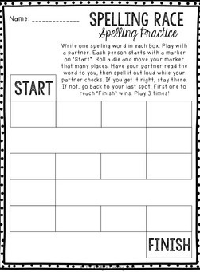  Details of Summer 2 spellings on class blog:  https://www.keyworth.notts.sch.uk/blog /?pid=9&nid= 6&storyid=1352  You can also use:  http://new/phonicsplay.co.uk
Community  Why not get involved with the Scouts great indoors weekender: https://www.scouts.org.uk/the-great-indoors/the-great-indoors-weekender/#!/  Here’s some more information:  From graduations to trips with friends, young people have missed out on all kinds of things this year. We think they deserve something really special – something for Scouts and non-Scouts, all around the globe – so we’re holding (cue big, boomy voice) The Great Indoors Weekender!  Join the UK’s biggest digital summer camp from your living room (or garden, anywhere at home – it’s up to you) on 11–12 July. With surprise celebrity guests, cooking, crafts, music and more, young people (6+) will get the chance to have fun while learning skills like giving stuff a go, thinking for themselves, and playing their part.  Get involved. Build a base camp (whether it’s a tent under the stars or a duvet dragged under the stairs), connect with us on a mobile, tablet, or computer, and you’re all set. There’ll be activities you can complete in your own time as well as live events, including a UK-wide campfire. | Wellbeing  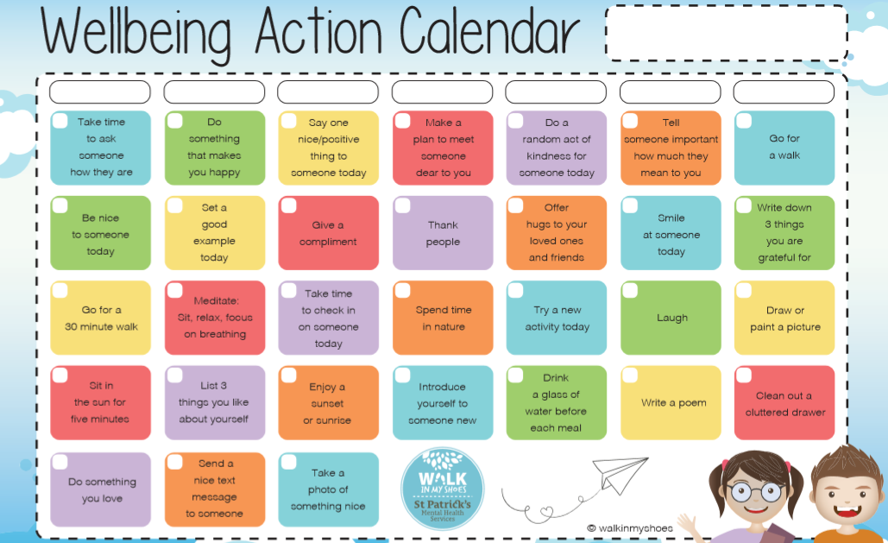  Please see below for a new wellbeing calendar you might want to choose activities from. |  | Family Fun ideas  - Build a bug house.  - Bake something.  - Do some gardening  - Follow a new recipe  - Do some Just dance!

