Home Learning Map – Year Three – Week Beginning 15/6/20
Remember that English, Maths and wellbeing skills should take priority but also just do what you can and stay safe!

Maths  - Complete at least 2 MyMaths lessons  Please see our new maths blog ‘white rose week beginning week 7’: https://www.keyworth.notts.sch.uk/blog/?pid=9&nid=38  for resources such as videos and worksheets.  - Have a go at the new Maths project: https://www.keyworth.notts.sch.uk/blog/?pid= 9&nid =6&storyid=1622  - Do your 5 a day on Doodlemaths every day- let’s try to earn the doodlemaths star!  - Log onto timestable rockstars every day and work on the timestables you are learning. In Year 3 we are focusing on the 3, 4 and 8 times tables.  Challenge: Can you create a times table game to help learn the division facts for the times tables you are learning. | PE  Complete 3 workouts.  - Bike ride / scoot  - Run/walk  - Just dance!  - P.E with Joe (You Tube)  - Cosmic Yoga (You Tube)  - Dance with Oti (You Tube)  - Skip  - Make up a throwing and catching game  Have a go at Miss Robinson’s Football activities from Rushcliffe’s Sports partnership: https://www.keyworth.notts.sch.uk/blog/?pid=9&nid=8& storyid=1574  Why not try some wildlife yoga:  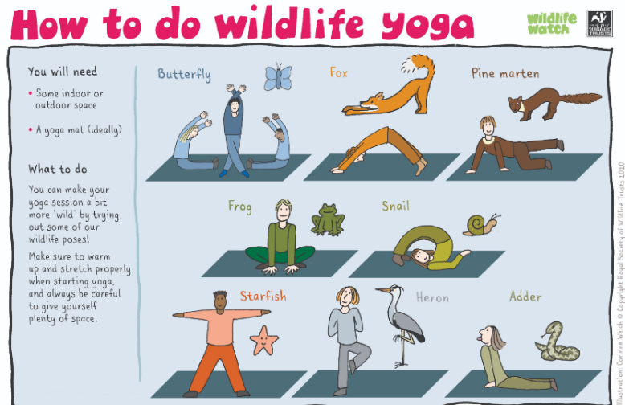 | Topic Projects  Computing:  Have a go at some coding with Scratch!  Lots of ideas and tutorials if you’re not sure  Where to start: Scratch ideas  Computing project for this week: https://www.keyworth .notts.sch.ukblog/?pid=9&nid=6&storyid=1688  Art:  Why not learn the Japanese art of Origami?  https://blog.britishmuseum.org/make-your- own-Origami-inspired-by-japaneseprints/?gclid=EAIaIQobChMI16 Wok9Xv6QIVFeDtCh3PSgnGEAAYASAAEgL TnfD_BwE  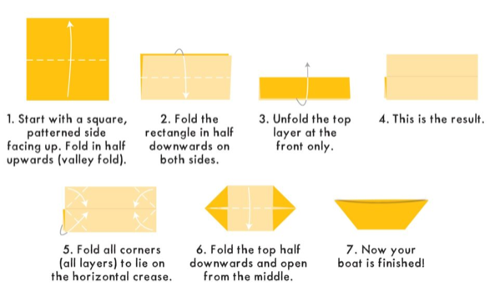  Geography: Why is the Earth made of layers?  (see home learning mat blog for resources).  This week I would like you find out about why the Earth  is made of layers. I would like you to watch the  powerpoint ‘Earth Layers’ and then complete the Earth’s  layers activity sheet. There is also a ‘layers of the  Earth’ poster and information sheet to help support this  activity.  You might even want to create your own model of the  earth’s layers first and then complete the activity:  http://momwifewine.com/2019/10/09/dyed-rice-layers-of -the-earth-3d-project/  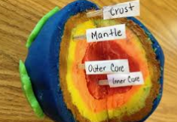  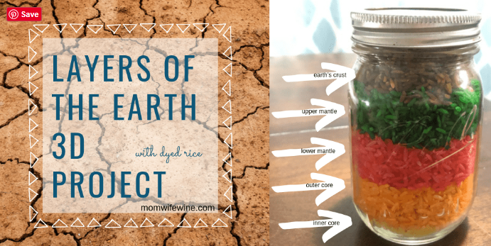  You could even create the earth’s layers by using chalk  outside!  Science: Why do rocks look different?  (See home learning mat blog for resources).  Start by looking at the ‘pebbles pictures on the beach’  using the document ‘discussion questions’.  Look at presentation ‘grouping rocks’.  Using the rocks you found in the previous week to help  with your experiment. You are going to be a  palaeontologist!  Activity 1: Complete the ‘properties of rocks’ worksheet.  Key words you will need:  Permeable: does it allow for water to pass through?  Durable: is it a hard wearing rock- will it break easily?  Density: If it’s high density it will sink and if its low  density it will float.  Activity 2: Complete the ‘grouping of rocks’ worksheet.  Extra Science: Choose 3 video clips  from the science topic ‘rocks, soils and fossils’ to  watch:  https://www.bbc.co.uk/bitesize/topics/z9bbkqt
Reading  Read every day for 15 minutes.  This can be a combination of you reading and also listening to or sharing books with others.  To listen to/read stories, go to:  Reading eggs (How many eggs can you earn?):  https://readingeggs.co.uk/  Oxford Owl’s Free e-book library https://www.oxfordowl .co.uk/for-home/find-a-book/library-page/  Audible’s free children’s books https://stories.audible.com /discovery  The Book of Hopes ebook:  Literacy Trust The Book of Hopes  Complete 3 reading eggs assignments and explore the islands. | Writing  Writing tasks will be partly based on the ‘National Oak  Academy’ lessons: https://www.thenational.academy/online-classroom/year-3/english#subjects  -Watch and complete at least 2 English lessons about ‘character description’ online at The National Oak Academy.  Complete the writing task:  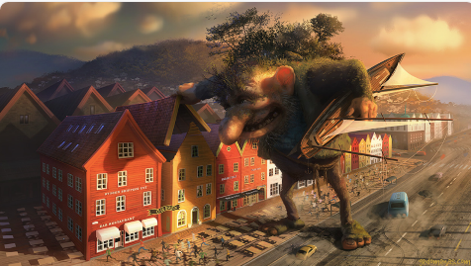  Your task this week is something different! I would like you to write a character description of this ghastly troll.  Describe his appearance, how the troll got to the town, describe how he speaks/moves, what he thinking and the troll’s personality.  Please use Oak academy lessons to support this writing task as well as resources on the home learning map blog (picture of troll & extra challenges, planning sheet and word bank).  **Bonus: Sentence stacking with Jane Considine: https://www.youtube.com/playlist?list=PL4ypPL9ZSf5o4yqGMm HlNuO-TmhmpXiTH |  | Spelling  Practice your weekly spellings  daily. This week, why not continue the  dictionary of the words you have learnt so  far this half-term and try and use these  in your writing.  Details of Summer 2 spellings on class blog:  https://www.keyworth.notts.sch.uk/blog /?pid=9&nid= 6&storyid=1352  You can also use:  http://new/phonicsplay.co.uk
Community  Why not write a letter to a class friend. You could then take a picture of your letter or email them to our class email and I can send them to your Sea Lion friend! | Wellbeing  Choose one of the activities from the latest wellbeing blog:  https://www.keyworth.notts.sch.uk/blog/?pid=9&nid=6& storyid=1609  Read the little poem about what makes a hero attached to the end of this learning map. |  | Family Fun ideas  - Create a family playlist with all  your favourite songs.  - Go on a nature  scavenger hunt in  your local area.  - Have a go at creating origami
