Tuesday 2nd February 2021
LO: To learn about a non-European society that provides contrasts with British history.
Chief Si’ahl (Seattle) is a famous 19th century Native American chief of the Duwamish tribe, whose tribal ancestral homelands include the area known today as the city of Seattle, Washington. He made this speech in 1854.
The speech talks about the relationship between the Native Americans and the non-indigenous peoples that fought with them over land.
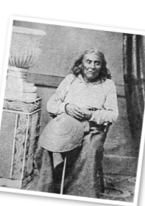
Read Chief Seattle’s speech and answer these questions.
- What phrases does Chief Seattle use to describe and compare the size of the tribal people with the white people?

- What does Chief Seattle say to tell his audience that there used to be a lot more of his people?

- What do you think Chief Seattle means when he says day and night cannot dwell together?

- What is Chief Seattle agreeing that his people will do?

- What do you think Chief Seattle means when he says “There is no death, only a change of worlds.”

- Who do you think Chief Seattle is talking about when he says the Big Chief at Washington?

