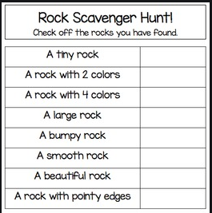

Rock Scavenger Hunt
Name:__________________ Date:_____________
Choose two rocks you have found, and lay them on a plain white piece of paper. Use the rock identification materials to identify the names of the rocks. Draw a picture of each of the rocks and write their name in the given space.
Rock Name/type of rock _____________________________________________
Rock Name/type of rock: ______________________________________________

