Design a Rocket
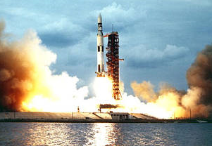
The Saturn V rocket, which took the Apollo Space flights to the moon, was powered by the largest engine ever built. It generated enough power to light the entire city of New York for 75 minutes.
Can you design a rocket and make it fly?
WALT
Record and present your findings
You might do this using:
- simple scientific language
- drawings
- labelled diagrams
Recording
We would love to see the rocket you make. Here are some ideas for how you could share it with us:
- A PowerPoint with pictures
- A video news report
- Photos
Questions to ask
- What will make it take off?
- How can you make it better?
- What is the science behind it? What knowledge did you need?
Further things to investigate:
- How much fuel did the Saturn V carry?
- What happened to it after it returned to Earth?
- How does it compare to other rockets?
- How was it tested?

