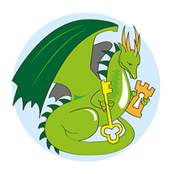

Tuesday 27th November 2018

Friday 27th May 2022

End of Year Performance
Oliver Twist

Dear Parents,

This year we have chosen to do the Dickens classic ‘Oliver Twist’ for our end of year performance. The whole school will be involved in this special rendition and the children have already been busy learning the songs during our Singing Assembly. Each class will become familiar with the story over the final half term of the year, and we will all be busy working to put on a performance you will never forget! Please read this letter carefully as it outlines what you need to know about this year’s End of Year Performance.

Costumes:
The show is set at the beginning of the Victorian era so we would like the children to wear costumes which will bring the period to life.
EYFS and KS1 children will be orphans and can wear something similar to below. Scruffy looking shirt and scraggy, patched trousers. They can wear their school pumps or bare feet. No bright colours please.

Key stage 2 children will be Victorian Children. They should wear a simple white shirt or blouse with plain dark trousers or skirt (the skirts could be long). A plain long dress would be fine too.

We will have a look in our school costume bags for little extras but if you feel like embellishing the costume…. here are a few ideas. Waistcoats, scarves and caps for the boys. Aprons, mop caps, straw hats or even a bonnet for the girls.
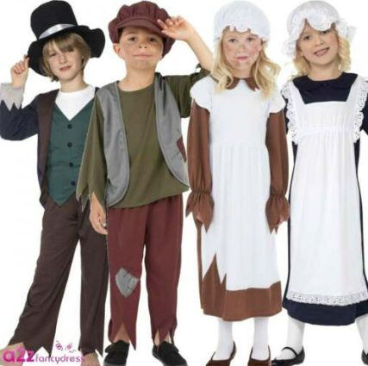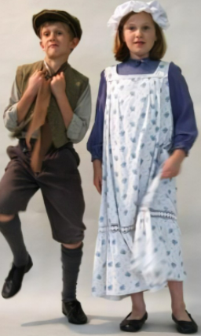

Please send costumes in no later than Monday 11th July in a NAMED plastic bag. If you have any questions, please ask your child’s class teacher or Mrs King.

Tickets:

You will need to order your tickets online using Eduspot School Money Website. The tickets will be available from the shop area at a charge of £1 per ticket. You can purchase tickets for the following dates:

Tuesday 19th July at 9:30am
Wednesday 20th July at 2pm
Wednesday 20th July at 6:30pm

Year 6 parents can order tickets over half term as a priority- they will be open to the rest of the school the first week back.

Each family will be able to order two tickets initially (unless your child is in Y6 and then you can initially order 4 if you require) and then additional tickets will be available after the 27th June. For health and safety reasons, we cannot exceed our maximum capacity of 120 people in the hall therefore people without tickets will not be admitted.

Funds raised by the selling of the tickets, will go towards our playground renovation project.

If you have any questions, please contact the school office or catch Mrs King or Miss Hopwood.

We look forward to seeing you all there.

Yours sincerely,

Mrs King.

