Getting to Know The Artist – Carl Warner
Visit his website. http://www.carlwarner.com/artist
Carl Warner is an artist that makes his pictures out of food!
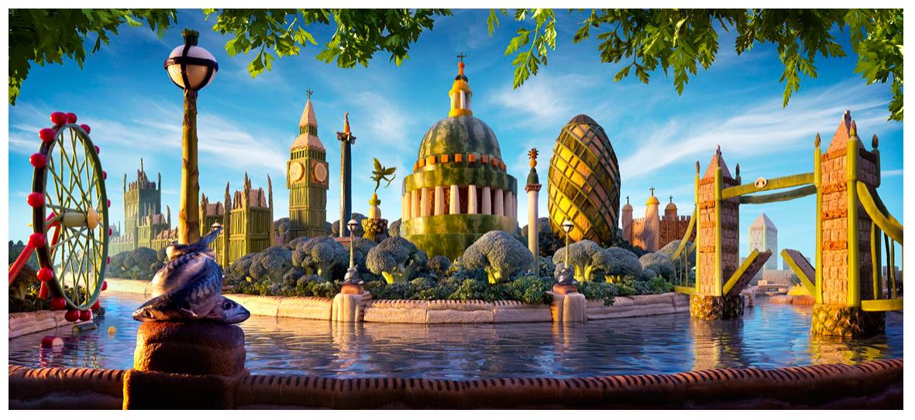
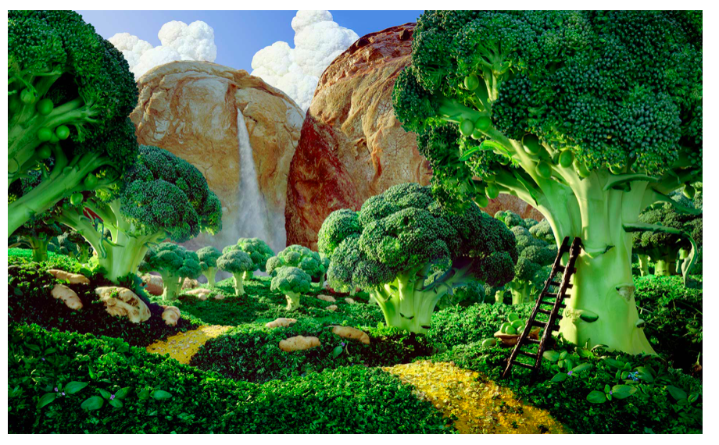
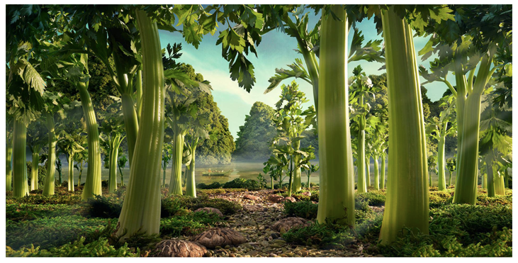
Look carefully at the pictures….
What is everything made out of?
You will often see his artwork used on adverts seen on the TV.
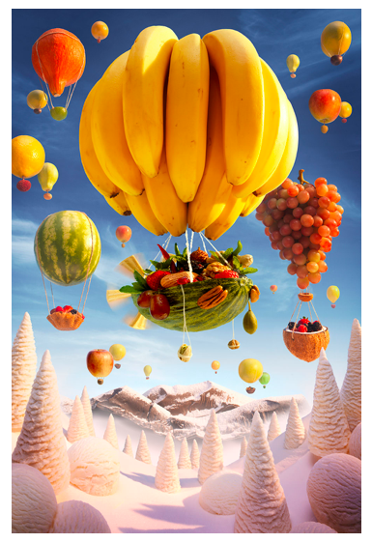

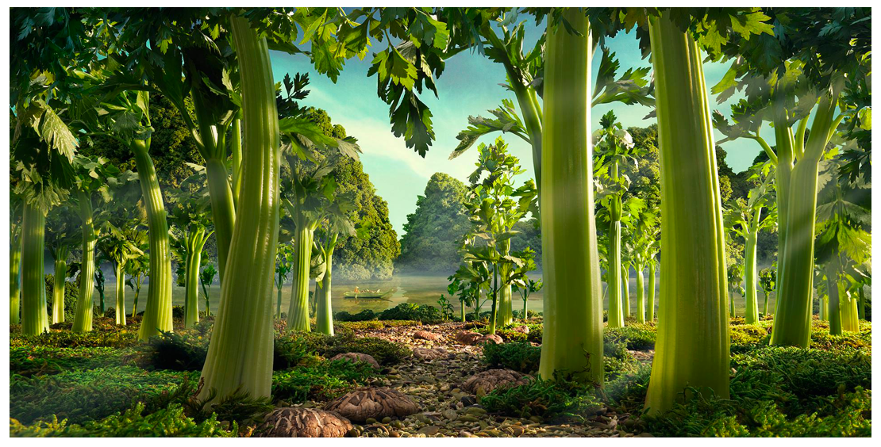

Watch this video and hear him talk about how he makes is artwork.
http://www.carlwarner.com/creative/the-one-show/
Then…… your challenge
Have a look in your cupboards and fridge……..plan what you could make by doing a sketch just like Carl Warner
Then let your creative juices flow and create your own FOODSCAPE
Send a picture of your foodscape!

