Task B- In the story ‘The Determined Rooster’, the rooster wanted his purse back. Can you remember how much he had in his purse? Have a go at counting how much is in these purses….

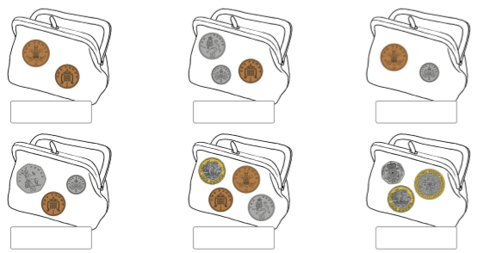

Now can you use the coins on the other sheet (or some you may have at home) and fill your purse with coins? How much do you have in your purse?

