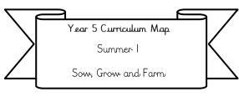

**Year 3 Curriculum Map**

**Spring 1**

**Who were the first people wo lived in Britain?**

**Literacy:** We will be writing holiday brochures based on the book ‘Prehistoric Britain’ by Dawn Finch

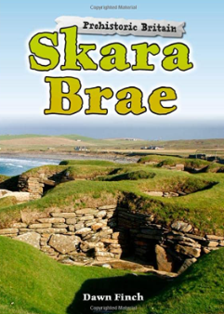 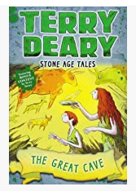 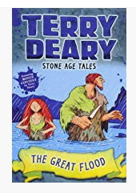

Our Class text: The Great Cave & The Great Flood by Terry Deary.

**Science:** We will be learning about light and shadows.

**Maths:**

**We will be covering** Multiplication and division and starting length and perimeter (please complete doodle extras related to this learning to reinforce this)

**Please also be practicing your**

**2, 5, 10, 3, 4 and 8 times tables.**

**RE:** Brave people in the Bible (Focus on Christianity).

**PE**/ **Swimming**: Swimming is on a Thursday afternoon for some children and if you’re not going swimming you will be doing football with Miss Robinson.

**PSHE: Dreams and Goals**

We will be looking at what our dreams and ambitions are and how we can reach these goals.

**History : Our big idea is: Who were the first people in Britain? (Please see Knowledge organiser for more information)**

**We will be mainly covering early Stone Age Britain questions we’ll cover include:** Why was the Stone Age called the Stone age? As well as what was life like in the different periods of the Stone age?

.

**Art (Painting and Printing):** We will be creating stone age cave paintings and created street art inspired by Banksy!

**ICT:** We will be learning how networks function and e-safety.