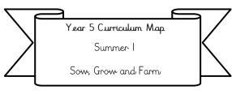

**Year 3/4 Curriculum Map**

**Summer 1**

**Misty Mountains**

**Literacy:** We will be writing water cycle factual tours and writing mountain setting descriptions.

Our Class text: Once upon a raindrop by James Carter

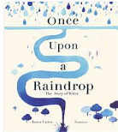

**Science:** States of Matter and exploring solids, liquids, gases and learning about famous scientists.

**Maths:**

**Year 3:** time, statistics, angles and shape.

**Miss Groves:** place value, adding and subtraction, multiplication and division.

**Year 4**: Timestable assessment in June, symmetry, time, statistics and angles.

**RE:** Mosques and Mohammed (exploring Islam)

**PE** is on every Wednesday and Thursday we will be doing Athletics, sports week and sports day this half-term!

**PSHE: Changing me-**

Please see blog for more information for each year group: [**Keyworth Primary and Nursery School - Important information- personal, social and emotional education- Jigsaw coverage**](https://www.keyworth.notts.sch.uk/blog/?pid=9&nid=11&storyid=2609)

**Geography/ICT:** What makes a mountain?

* What makes a mountain and how are they formed?
* What types of mountains can you find?
* World Mountains and mountains found in the UK.
* Mountains and tourism.

.

**Music:** Ukulele every Tuesday and preparing for our Summer performance of Oliver!

**Art:** Landscape painting.