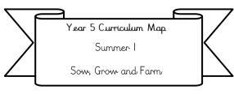

**Year 3 Curriculum Map**

**Autumn 1**

**Extreme Weather**

**Literacy:** We will be writing fact files based on Muhammad Ali and writing Autumn poems.

Our Class text: Muhammad Ali Big People Little dreams.

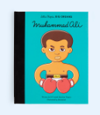

**Science:** We will be learning about animals including humans.

**Maths:**

**We will be covering** Place Value and Addition/Subtraction.

**Please also be practicing your 2, 5, 10, 3, 4 and 8 times tables.**

**RE:** Signs, symbols and Parables (exploring Christianity).

**PE**/ **Swimming**: Swimming is on a Thursday afternoon. In PE, you will be working with Miss Robinson and playing football and tag rugby!

**PSHE: Being me**

We will be learning about ourselves as individuals.

**Geography: Our big idea is: What is extreme weather and how does it affect people?**

**We will be mainly covering** storms, tornado alley, extreme heat and extreme cold.

.

**DT:** We will be designing cool boxes which will withstand extreme heat.

**ICT:** We will be learning how to use programming software such as Scratch.