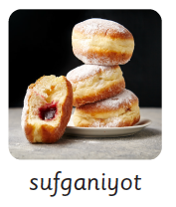

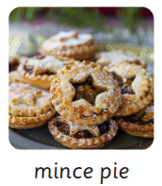

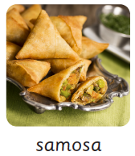

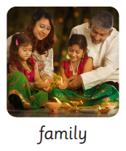

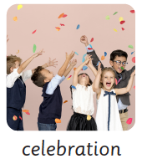

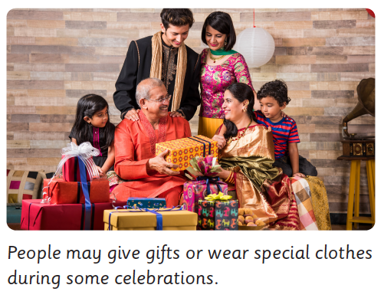

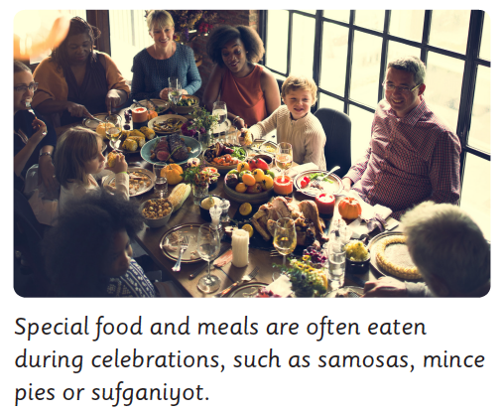

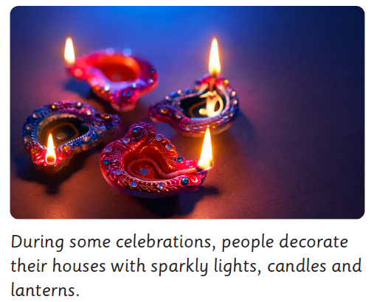

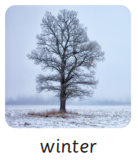

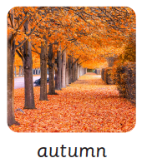

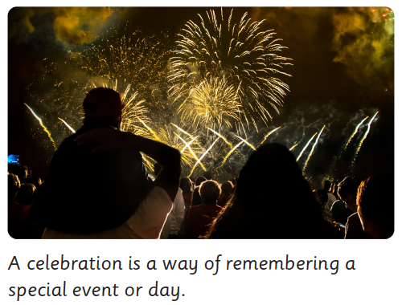

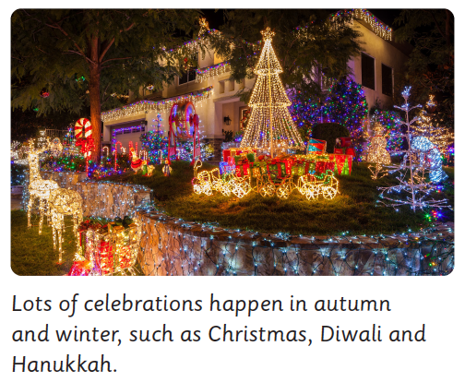

Our ‘Big Idea’: Sparkle and shine

I am going to find out what a celebration is.

I am going to compare different celebrations that take place

in the Autumn and Wintertime.

I will find out why many of these celebrations involve using lights.

Do you know?

Key Vocabulary

Enquiry Questions

What is a celebration?

What special things do you celebrate?

Does everybody celebrate the same things?

Why do lots of celebrations use light?

When you celebrate……

Do you have any special food?

Do you wear special clothes?

Do you go somewhere special to celebrate?

Who do you celebrate with?

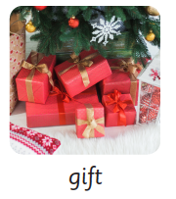

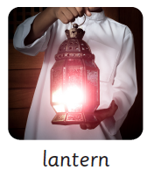

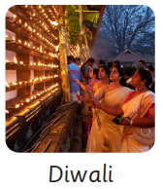

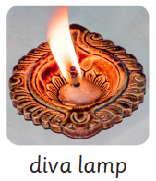

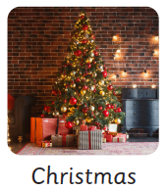

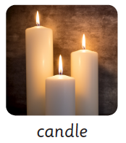

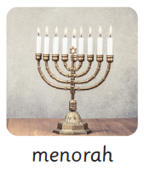

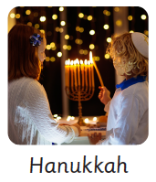

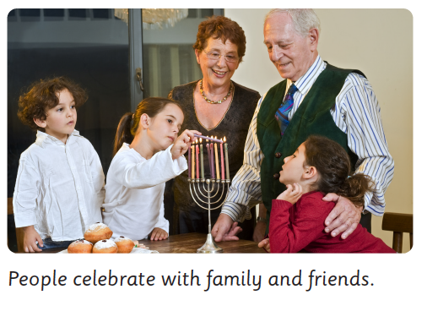

After exploring all of these enquiry questions I will be able to:-

Tell you that a celebration is a way of remembering a special day or event

Tell you the name of autumn/winter celebrations that use light to celebrate.

Talk about the similarities and differences between the celebrations at this time of year.

Talk about how and what I celebrate at home, which may include :- the food I eat,

the clothes I wear, the gifts I exchange and who I celebrate it with.

