Year 2: Piece 4 & 5
LO: To work cooperatively in a group to create an end product and explain some of the ways I worked cooperatively.
Ask an adult to read the calm me script to you and ensure you are sitting comfortably:
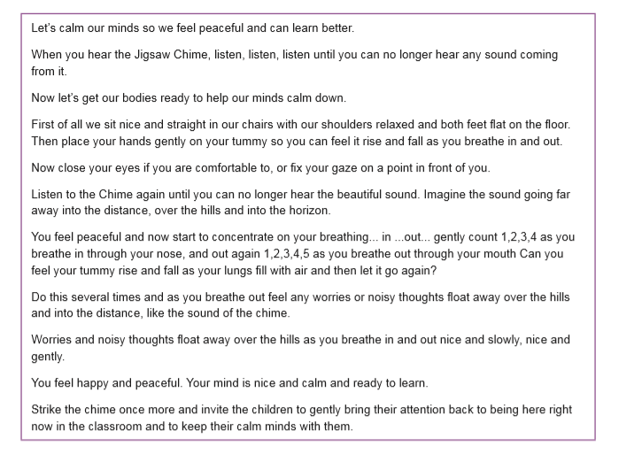
Then read the charter as a family:
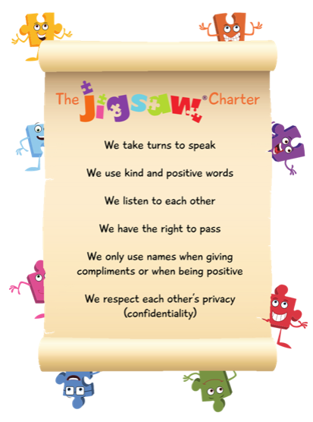

Quick activity:
- Play ‘Pass the ball’. Standing in a circle, the children throw a ball to each other. One person starts by throwing the ball across the circle, that person then throws the ball to someone else in the circle.
- The children have to concentrate, cooperate and work together to achieve this task. Then, time this activity so that you know how long this task has taken.
- Then ask the children to see if they can work together to do this task again but beat their time!
- How can they do this? What skills/strategies do they need to use to achieve this? Then have a go!

This week in Jigsaw I would like you to think about these questions with your families:
- Remind yourself of your goals you wanted to work on before half-term what were they?
- Is it easier to work on a goal with someone you get on with? Why? Why not?
- Dicsuss what some of these words mean: learning together, success, celebrate, achievement, challenge, product, dream, team work, problem-solve.

Your activity:
Explain to the children that their challenge in groups is to make some imaginary birds for ‘A Garden of Dreams and Goals’.
- Working cooperatively as a family to create an imaginary dream bird that might live in the garden of dreams and goals. You can use any materials you have- paper, pencil, felt tips, cardboard etc to make your dream bird.
- Think about the colours and shapes you might use. This is a garden of dreams and goals so they can use their imaginations. It is a happy, safe garden with nothing scary in it.
- Explain that this task is about making the dream bird but also learning about how to work as a team.
- As the children as they work on their dream birds questions such as: • Has everyone on your group got a job? • Is everyone clear in your team clear on the design of your bird? • Is everyone clear in your team what their role is? • Have you got any ideas about how to solve problems when people in the group disagree? • What’s working well?
Here’s a few examples of what your ‘dream bird’ might look like:
