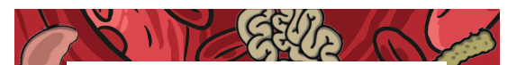
Open wide – let’s look inside! We’re on a voyage of discovery to investigate the busy world inside your body.
This half term, we’ll find out about different dental procedures and learn new scientific vocabulary. There will be lots of investigating as we learn about our different teeth, how to brush them and how sugary drinks affect them. We’ll examine the amount of sugar in different foods and create images of ourselves with healthy and unhealthy teeth. We’ll write an explanation text describing the journey a piece of food takes through the digestive system. In science, we’ll learn about the organs involved in digestion. We’ll also learn about digestion in different animals and handle a range of digestive organs.
Help your child prepare for their project:
The food we eat goes on an amazing journey through the digestive system. Why not keep a joint food diary for a week to see if you eat enough gut-friendly foods? You could also try a new food or drink that you’ve never tasted before. What do you like or dislike about its taste and texture? Alternatively, drop copper coins into a range of fizzy drinks overnight to see what happens. Which drink has the most powerful cleaning properties?

English | Explanation texts and poetry.
Maths | Fractions, Decimals and mass/capacity
Science | Teeth types; Tooth decay and hygiene; The digestive system; Working scientifically
Computing | Images; PowerPoint and excel.
RE | Miraculous Escapes
Music | Ukulele
Jigsaw | Healthy me

