Activity 1 – Numbers to 100

Fill in the missing numbers
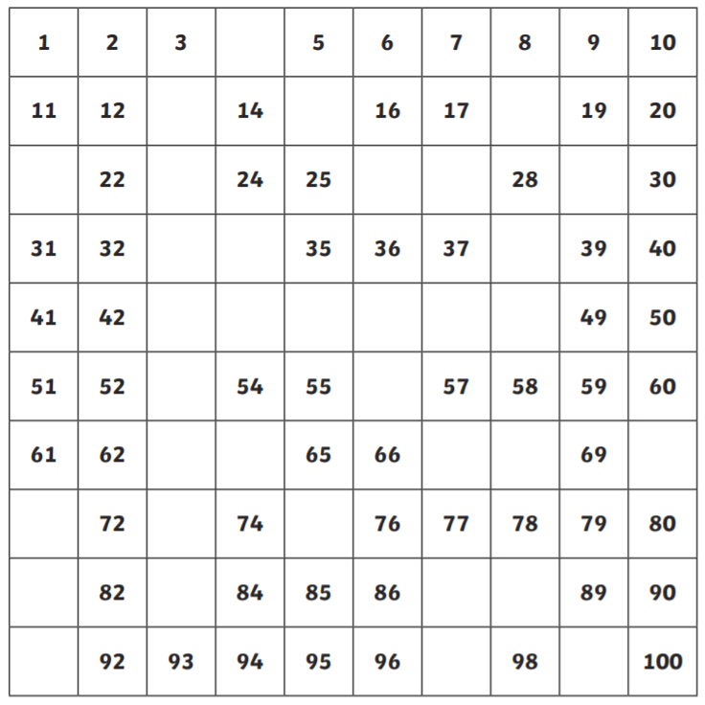

Complete the number sequences – Some go FORWARDS and some go BACKWARDS

12, 13, 14 ___ ___ ___ 24, 25, 26 ___ ___ ___
30. 29, 28 ___ ___ ___ 57, 56, 55 ___ ___ ___
27, 28, 29 ___ ___ ___ 51, 52, 53 ___ ___ ___
61, 60, 59 ___ ___ ___ 73, 74, 75 ___ ___ ___
Activity 2 – Numbers beyond 100
Fill in the missing numbers
71 | 72 | 73 |  |  | 76 | 77 |  | 79 | 80
 |  |  |  |  |  |  |  |  | 100
101 |  |  | 104 |  | 106 |  |  | 109 | 110
 | 112 | 113 |  | 115 |  |  | 118 | 119
121 |  | 123 | 124 |  |  | 127 |  |  | 130

Which number comes after 74?
Which number comes before 91?
Which number comes after 107?
Which number comes before 116?
Write down all the numbers between 117 and 125
I start counting forwards from 84. Will I say 78?
Yes / No How do you know?
___________________________________________________________________________________________________________________________
Activity 3 – Tens and ones
How many tens and ones? What is the number?

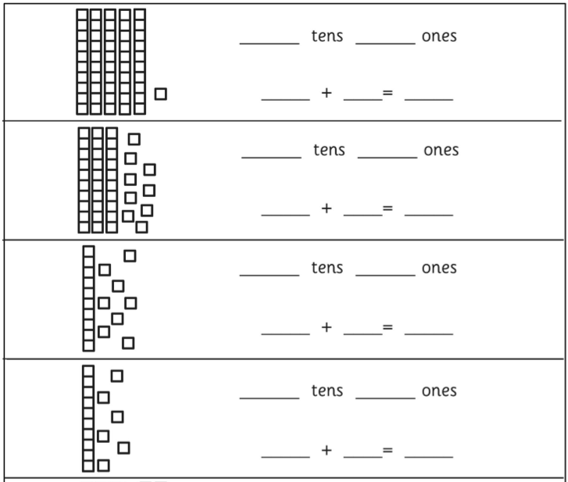

1
5
51

Match the picture to the tens and ones

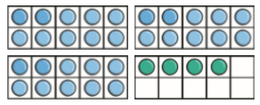 2 tens and 4 ones

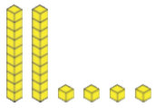 4 tens and 3 ones

3 tens and 5 ones

2 tens and 0 ones

3 tens and 4 ones

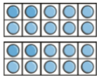 0 tens and 8 ones

