I can work out how to achieve a goal
Ensure you are sitting comfortably and ask an adult to read the ‘Calm Me’ script. You may want to listen to something relaxing like this on YouTube!
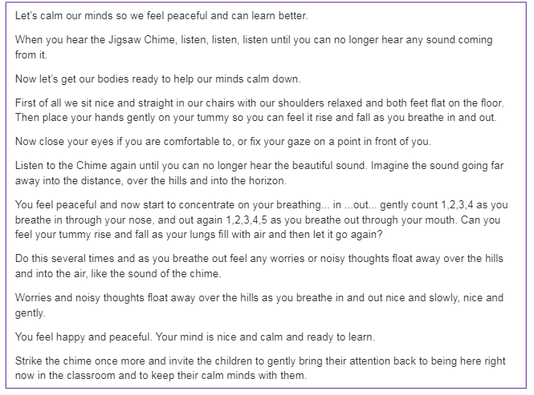
Then read the charter as a family:
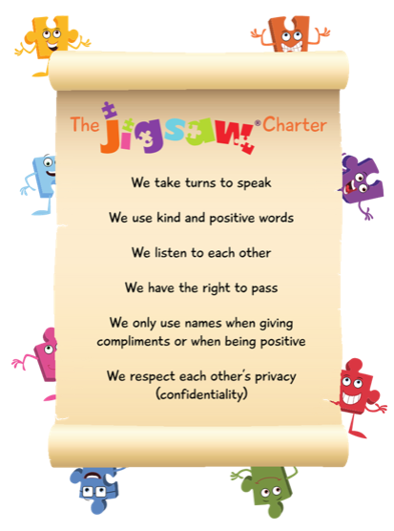

Preparation
For this lesson you will need the necessary ingredients/equipment to make a jam sandwich.
Set out for pieces of paper like stepping stones on the floor leading to a tray filled with everything you need to make a jam sandwich.

Activity
Explain the goal for today’s lesson is to make a jam sandwich and the pieces of paper on the floor are like stepping stones. Each one is a step towards the goal. A sandwich doesn’t just suddenly appear, it has to be made, and making it is a step by step process.
Have a chat about what the steps could be to making the sandwich then get your child to instruct you. If something goes wrong, discuss how it could be fixed and try again.
If you wish, you could complete the cut and stick activity on the next page.

Discussion
What did our activity teach us about how to achieve a goal? Here are some things you may want to discuss:
- goals don’t just happen – we have to work for them one step at a time
- we can achieve goals by figuring out each step
- other people can help us with these steps
- it’s okay if something goes wrong
- things that can help us achieve goals are to listen, watch and have a go ourselves

