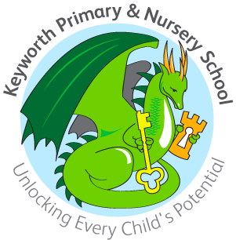
KEYWORTH PRIMARY & NURSERY SCHOOL

Application Form For Nursery Sessions

Name _____________________________ Date of Birth_______________

Name of Parent/Carer(s)_________________________________________

Address_____________________________________________________

____________________________________________________________

Telephone______________________ Mobile_________________________

Email address _________________________________________________
I would like my child to attend Nursery on the following sessions:

 | Monday | Tuesday | Wednesday | Thursday | Friday
Morning
Lunch session
Afternoon

The free entitlement for your child in the term after they have turned 3 is 15 hours unless you are entitled to the 30 hour funding.

My child can access to the 30 hours entitlement: yes / no (code and must be provided once sessions confirmed)

If you are not entitled to the 30 hours additional sessions can be paid for as follows:
Lunch time 12pm till 1pm - £3
(school meal can be provided at a cost of £2.40 or you can provide sandwiches)
Additional morning /afternoon - £8.50

Any additional sessions must be booked in advance.

I understand that I must give half terms notice of any changes.

Current/previous Pre school or Nursery : _____________________________

Signature of parent/carer___________________________Date__________

