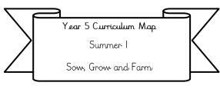

**Science:** We'll investigate how water travels through a plant’s stem, discover the amazing ways plants reproduce, and learn how seeds are dispersed in nature. Get ready for some hands-on experiments and exciting discoveries!

**Literacy:** We will be writing discussion-based texts based on the text ‘Should Mrs Mac let the boys out again?’.

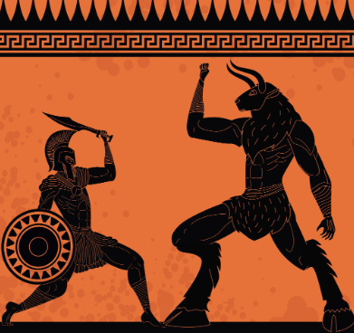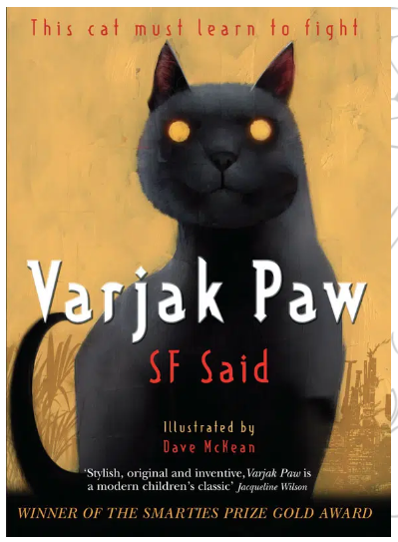

Our Class text: We will be continuing Varjak Paw by SF said and reading Greek myths.

**Year 3 Curriculum Map**

**Summer 2**

**How did Ancient Greek life impact on us today?**

**Maths:**

**We will be covering** time, shape and statistics (please complete doodle extras related to this learning to reinforce this)

**Please also be practicing your**

**2, 5, 10, 3, 4 and 8 times tables- this is a crucial and will support you greatly in Y4.**

**RE:** We’ll be learning about special places in Christianity, focusing on why Christians might choose a particular church, the different features found within a church, and the special events that take place there.

**PE: will now take place every Wednesday and Friday afternoon.**  
This term, we’ll be learning how to play tennis and developing our skills in athletics through a variety of fun and challenging activities.

**PSHE: Changing Me**

We will be looking at the topic ‘changing me’ please see our class blog to find out more about this ‘Jigsaw coverage after half term Summer 2’.

**ICT:** We’ll be diving into the world of podcasts to learn how they’re made and what makes them effective.  
Our learning will include understanding what a podcast is, exploring how volume and audio quality affect the listener’s experience, and developing our editing skills to create and refine our own podcast episodes.

**History : Our big idea is: How did Greek life impact on us today? (Please see Knowledge organiser for more information)**

**We’ll be exploring the fascinating world of the Ancient Greeks—who they were, when they lived, and the legacy they left behind.**  
We’ll examine real Ancient Greek artefacts to uncover what they reveal about life in that time, and investigate how Ancient Greek ideas, inventions, and culture continue to influence our society today.

.

**Art:** We’ll be getting creative with clay as we design and make our own vessels, inspired by the Ancient Greeks We’ll explore examples of Greek vases to understand their purpose and designs, learn how to use the coil technique to shape our own vases, and then bring our ideas to life by crafting unique clay creations.

**Music:** We will be looking at the units ‘Chilled-out’ and ‘clap rap’ we will also be preparing for our summer performance. We will be focusing on rhythm and beats.