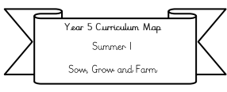
Year 3 Curriculum Map
Spring 1
Who were the first people wo lived in Britain?
Literacy: We will be writing a portal story based on the text ‘The Garden’.
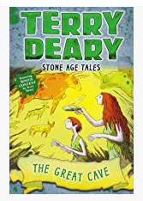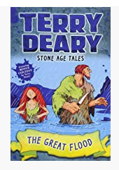
Our Class text: The Great Cave & The Great Flood by Terry Deary.

Science: We will be learning about light and shadows. We will be looking at what light is, how it travels, what colours show up best in the dark as well as how light is reflected from mirrors.

Maths:
We will be covering Multiplication and division and starting length and perimeter (please complete doodle extras related to this learning to reinforce this)
Please also be practicing your
2, 5, 10, 3, 4 and 8 times tables.

RE: Brave people in the Bible (Focus on Christianity). We will be looking at Noah from Noah’s Ark, Abraham, and Hannah and Samuel.

PE: The children will be taking part in PE Monday afternoon; we will be working on fitness and hockey. On a Thursday the children will continue working on their swimming skills.

PSHE: Dreams and Goals
We will be looking at what our dreams and ambitions are and how we can reach these goals. We will be looking at responsible choices, conflict and learning from challenges.

ICT: We will be learning how networks function and e-safety. We will be working on how networks work, and how they offer opportunities for communication and collaboration.

History: Our big idea is: Who were the first people in Britain? (Please see Knowledge organiser for more information)
We will be mainly covering early Stone Age Britain questions we’ll cover include: Why was the Stone Age called the Stone age? As well as what was lifelike in the different periods of the Stone age?
.

Art (Painting and Printing): We will be creating stone age cave paintings and created street art inspired by Banksy!

French: This half term will be working on our phonetics and pronunciation as well as how to order different quantities and flavours of ice-cream.

