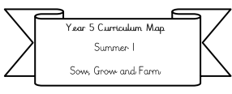
Science: The children will explore what a force is, how different surfaces can affect the way objects move, and how magnets work. They will investigate magnetic attraction and repulsion, test which materials are magnetic, and learn how magnets are used in everyday life.

Literacy: We will be writing information texts based on the text ‘The River Unicorn’.
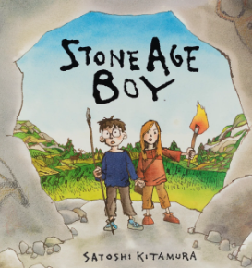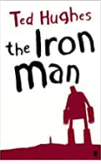
Our Class text: Iron Man by Ted Hughes

Year 3 Curriculum Map
Spring 2
Who were the first people wo lived in Britain?

RE: In RE, we will be learning about Hinduism, with a focus on how and why Hindus worship. The children will explore what Hinduism is, what Hindus believe about God, and why God is so important within the Hindu faith. They will also learn about different ways Hindus worship, including how puja (worship) can take place at home through the use of a shrine, special objects, and daily rituals.

Maths:
We will be covering Fractions and starting mass and capacity (please complete doodle extras related to this learning to reinforce this)
Please also be practicing your
2, 5, 10, 3, 4 and 8 times tables.

Swimming/PE: The children will be continuing with their swimming lessons every Thursday afternoon.
PE is on every Friday afternoon

PSHE: Healthy Me
In our Jigsaw ‘Healthy Me’ unit, we will be learning about what it means to live a healthy lifestyle. The children will explore how to keep their bodies fit and healthy, the importance of physical activity, and how the choices we make can impact our overall wellbeing.

ICT: In our ‘iData’ module, the children will learn how to collect, organise and store data using simple data-handling tools. We will also be completing our ‘iSafety’ unit, where the children will learn how to stay safe online, make sensible choices when using technology, and understand what to do if something worries them while they are on the internet.

History: Our big idea is: Who were the first people in Britain? (Please see Knowledge organiser for more information)
In History, we will be exploring life in Britain during the Bronze Age and Iron Age. The children will investigate questions such as: Why do we call these periods the Bronze Age and the Iron Age? How did new materials like bronze and iron change people’s lives? And what was everyday life like during these times?
.

DT: In Design and Technology, we will be exploring how levers and pulleys can be used to create movement. The children will investigate different types of levers and then apply their learning to design and make a moving character inspired by the Bronze Age. This project helps develop problem-solving skills while linking creatively to our History topic.

Music: We will be looking at the music topics ‘From a Railway Carriage’ and ‘Just 3 Notes’. We will be focusing on structure, timbre and beat.

