
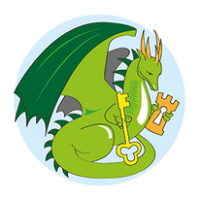

Monday 8th September 2025
Dear Year Three Parents,
Residential Visit to Beaumanor Hall 19th- 20th of March

We usually run a one night residential for our Year 3 children. The trip has been organised to celebrate their completion of Key Stage One and to give the children an opportunity to develop skills which will stand them in good stead as they embark on their Key Stage Two journey. Skills such as teamwork, communication, resilience, problem solving, independence and many more will all be built upon during this fantastic trip.

We will be taking the children to Beaumanor Hall on the 19th-20th of March where they will participate in a range of activities including: survival training, night line obstacle course, team challenges and be given time to explore the extensive grounds. The children will stay overnight in cabins and enjoy some delicious, home-cooked food.

Because Beaumanor Hall is so close, and to try and keep costs down, we are asking that children be dropped off and collected by their parents. Miss Fowell and I will host a parent information evening in February so that parents can receive a full itinerary and ask any questions they may have about the trip.

The trip will cost £125 per child and all payments must be made on Arbor. Using this system, you can pay the full amount in one go or in instalments. We are asking for a non-refundable deposit of £30 to secure our booking by Friday 17th October.

Any questions, please don’t hesitate to contact me ring the school office.

Gemma King
Head of School

