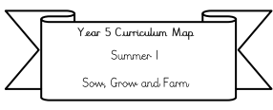
Science: We will be learning about plants. This includes: What do plants need to grow? What are the different parts of a plant and what are their function? What are roots? As well as how plants transport water.

Literacy: We will be writing warning stories based on our text for this half-term ‘The Canal’.
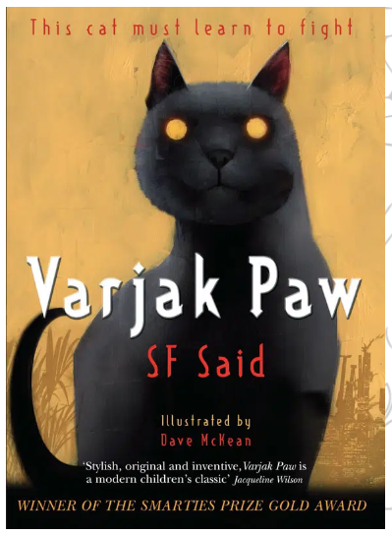
Our Class text: Varjak Paw by SF said.

Year 3 Curriculum Map
Summer 1
Why are rivers so important?

RE: Amazing rollercoasters in the Bible (with a focus on Christianity). This includes how the Bible is assembled. Who was Jonah and what was his journey? As well as who was Joseph and what happened in his early life?

Maths:
We will be covering mass and capacity, fractions, money and time (please complete doodle extras related to this learning to reinforce this)
Please also be practicing your
2, 5, 10, 3, 4 and 8 times tables this will support you greatly in Y4.

PE is now on every Thursday and Friday afternoon and the children will be taking part in rounders and cricket.

PSHE: Relationships
We will be looking at relationships such as managing friendships, family roles and responsibilities and being safe online.

Geography: Our big idea is: Why are rivers so important (Please see Knowledge organiser for more information)
We will be covering features of rivers, longest rivers in the world, human impacts on rivers and a study on the River Trent.

We’ll also be taking a trip to Perlethorpe which is based alongside the River Meaden.

.

ICT: We will be looking at a topic called ‘inconnect’ as well as isafety. The iconnect topic includes: the differences between the internet and the world wide web and how to use search engines safely and effectively.

Art: We will be looking at the artist David Hockney and creating our own acrylic painting of a river landscape. They will also take some of Hockney’s famous paintings and use/draw and replicate different viewpoints using various drawing and painting media. They will recreate in the style of Hockney and use a picture of a famous painting, At the end of the unit they will produce a final piece of artwork using acrylic paint.

French: We will be working on our phonetics and pronunciation as well as learning fruit names and quantities of fruit.

