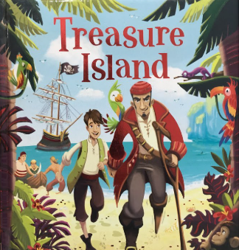
We are pleased to announce our Summer Performance this year will be…

We are looking forward to putting on a fantastic performance. Please help make it special by providing your child with a costume as outlined below. All costumes to be in school no later than Friday 3rd of July in a named carrier bag.

Children in Foundation are little mice:
Please provide your child with a grey t-shirt and grey leggings or trousers. We will make ears in school!


Children In Years 1 and 2 are Villagers:
Please provide the following:
- Boys- White shirts, knee length trousers, long socks, shoes.
- Girls- White blouses and full-length skirts.

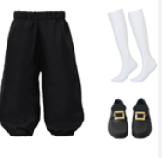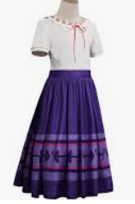

Children In Years 3, 4,5 and 6 are pirates:
Please provide your child with a pirate-style costume.

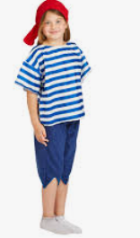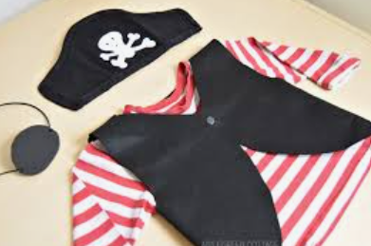

We will be sending information about how you can book your tickets over the next couple of weeks. But in the meantime, put the following dates in your diary:
Tuesday 21st July- Morning Performance
Wednesday 22nd July- 2pm and 6:30pm (Please put the evening performance in the diary so all the children can attend).

